Upton Village Hall  Upton Village Hall is situated in Cargate Lane and stands within a large green space, including football pitches, a children’s play area and a teenage/adult exercise area.  The hall has a main area approximately 108 m², a well-equipped kitchen, toilets block and a car park holding approximately 45 to 50 cars.  The hall is used by many groups including exercise classes, a Women’s Fellowship, Upton Horticultural Society and Upton Parish Council.  The hall is reasonably priced, making it an ideal venue for training sessions, family gatherings and children’s parties. The three south-facing doors open out onto a patio and give access to the grass beyond.  Contact details can be found in the Marshland Mardler (Upton’s parish magazine), a copy of which is enclosed.  Booking secretary:  Anne Lubbock 07554 497 720 or bookings.uptonvh@gmail.com | Upton with Fishley  Parish Council  The Parish Council pays for the grass cutting around the village and looks after the churchyard, cemetery, play area, playing field, boat dyke, staithe and pond. The councillors give their comments on local planning applications and are consulted on many local and national issues. Residents are welcome to ask questions at the beginning of each meeting, and any issues for the agenda should be sent to the clerk about a week before the date of the meeting.  The meetings are usually held on the 1st Thursday of each month, (no meeting is planned for August), at 7.30 pm in the village hall. The agenda for each meeting is posted on the three village noticeboards and on the website.  The councillors are Philip Armes (Chairman), Debbie Durrant (Vice-Chairman), Nigel Brennan, Ian Cook, Laura Davey, William Leonard-Morgan and Lee Smith.  The Parish Clerk is Pauline James  Tel: 01493 751070  Email: UptonPCclerk@gmail.com  http://uptonwithfishleypc.norfolkparishes.gov.uk/  and Facebook | Who Does What?  Broadland District Council  The Horizon Centre, Broadland Business Park, Peachman Way, Norwich NR7 0WF  01603 431133  - Collects bins  - Deals with planning  - Council tax  - Housing  - Licensing  District Councillors:  Nigel Brennan  cllr.nigel.brennan@broadland.gov.uk  Paul Newstead  cllr.paul.newstead@southnorfolkandbroadland.gov.uk  Norfolk County Council  Martineau Lane, Norwich NR1 2DH  0344 800 8020  - Highways and potholes  - Education and social services  - Public footpaths  County Councillor:  Fran Whymark tel: 07907163123  Fran.whymark.cllr@norfolk.gov.uk  Acle Medical Centre: 01493 717796
St Margaret’s Church |  | The Marshland Mardler
Welcome to Upton from St Margaret’s, the parish church of Upton.  St Margaret’s offers everyone a warm welcome. Times of services are on the notice board outside the church and also in the leaflet, Parish News, which is delivered to you bi-monthly.  Most services are at 9.30am on Sundays. There is normally a service of Holy Communion on the first Sunday of each month and then Morning Prayer or family service on other Sundays, except for the third Sunday, when there is Holy Communion at Fishley Church at 9.30am.  The vicar for the Blofield benefice, which includes Upton and Fishley, is Kevin Billson:  01603 712299.  The “Friends of St Margaret’s Church” is a group which helps maintain the church building for future generations. Subscription forms can be picked up at the community shop or from one of the churchwardens.  Churchwarden:  Joyce Warren 01493 752237 | 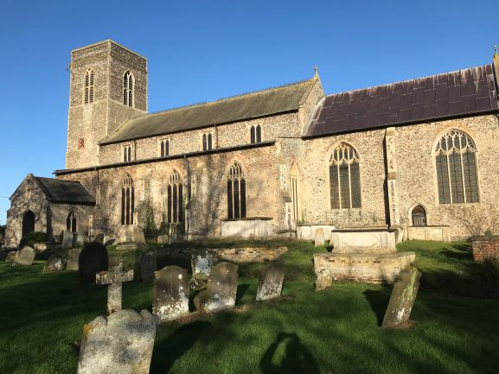  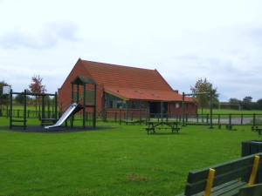  Upton Village Hall and Play Area | The Mardler is a monthly magazine covering Upton and neighbouring villages. It advertises local events and businesses and can be delivered to your door for an annual subscription of £7.  There are a number of social events in the village.  Editor:  Sally Hodges  SallyHodges1989@gmail.com  The White Horse Pub  The Pub is owned by the community, as is the shop next door. Without these facilities the village would be very much the poorer. They will welcome your support.  White Horse pub: 01493 750696  https://www.facebook.com/whitehorseupton  Community Shop: 01493 751827  Opening Hours  Monday - Friday: 8am – 6pm  Saturday & Sunday: 8am – 4pm (winter)  8am to 6pm (summer)

